Facilitating Humans:
The art of communicating in a meeting-centered workplace

Professor Michael Roberto’s 4 C’s of critical decision making
1. Control: What do you want to get out of the meeting?
ASK THESE QUESTIONS:

- What do I “know” already?
- Are there any peripheral touch points?
- What is the root question to be answered?
- What are the potential problems?
2. Composition: Who should be there?
4 roles:

- The Devil's Advocate
- The Facilitator
- The Decision Maker
- The Subject Matter Expert
3. Communication: Managing the individual needs of your group
remember:

- Be aware of your own biases toward types of people like those who repeat themselves and introverts
4. Context: What makes people want to come to your meetings?
remember:

- Set the mood and expectations (food, ambiance, etc.)
- Get there early and end 20% early

Information Architecture concepts
1. ontology: A shared understanding
2. taxonomy: A shared vocabulary

What type of meeting are you running?

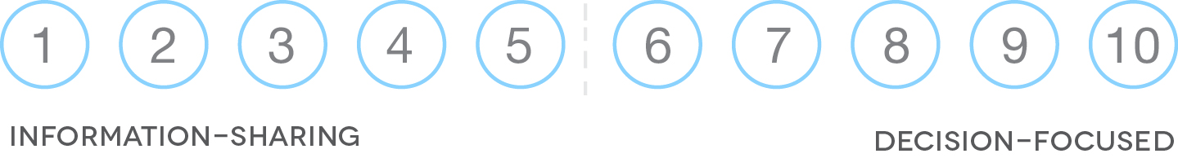

References
- Klyn, Dan. “Poster for Information Architecture Summit 2013”. 6 April 2013. Web.
<http://wildlyappropriate.com/2013/04/06/poster-for-information-architecture-summit-2013/>
- Roberto, Michael. “Art of Critical Decision Making”. 2009. Lecture.
- Tufte, Edward. Visual Explanations. Cheshire: Graphics Press, LLC, 1997. Print.

Caitlin Potts, UX Practitioner caitlin.potts@covenanteyes.com @caitlinpotts MI UPA (June 2013)

